SIMATS ENGINEERING (SAVEETHA SCHOOL OF ENGINEERING)
Department of Computer Science and Engineering
CO1 ASSESSMENT TOOL 2 – Agile Sprint Planning & user story workshop
Course Code: | CSA10 / CSA1004 | Course Title: | Software Engineering
CO Assessed: | CO1 | Assessment: | Assessment Tool 2 – Agile Sprint Planning & user story workshop
Weightage: | 20% | Total Marks: | 25
CO1 Statement: | Apply advanced methodologies and agile project management techniques to manage software projects effectively
Student Name: | SRIMATHI B | Reg. No.: | 192511448
Date: | 10/10/2026 | Duration: | 60 minutes

Code of Conduct
I SRIMATHI B (192511448)) (Name / Reg No) certify that this submission is my original work and that I have adhered to the guidelines specified for this assessment. I understand that any violation of academic integrity rules will result in disciplinary action.
Signature of the Student: ________Srimathi b_________________
Annexure A – Case Study Analysis

CASE STUDY ANALYSIS

SECURE ONLINE EXAMINATION MANAGEMENT SYSTEM

1. Understand the problem statement

  - Problem description
- Educational institutions conduct examinations to evaluate students' knowledge and academic performance. Traditional examination systems involve several manual activities, including preparing question papers, scheduling examinations, verifying student identities, evaluating answer sheets, calculating marks, and publishing results. These activities require significant time, effort, and administrative resources.
- The secure online examination management system is a software application designed to manage examinations through a secure digital platform. It provides a centralized environment for administrators, faculty members, students, evaluators, and examination department staff. The system simplifies the examination process by automating important activities and maintaining examination information in a database.
- The proposed system allows faculty members to create and manage question banks, administrators to schedule examinations, and students to attend examinations online. It authenticates students before allowing access to examinations and records their answers securely. Objective-type questions can be evaluated automatically, while descriptive answers can be evaluated by authorized faculty members.

- The system also generates results, prepares performance reports, and maintains audit trails of important activities. These features help improve examination security, reduce administrative workload, and provide faster result processing.

1.2 objectives of the system
the main objectives of the secure online examination management system are:

1. To maintain a centralized question bank.
2. To schedule examinations and manage examination timetables.
3. To authenticate students securely before examinations.
4. To provide an online platform for conducting examinations.
5. To automate the evaluation of objective-type questions.
6. To maintain accurate examination and student records.
7. To generate results and performance analytics.
8. To maintain audit trails for transparency and accountability.
9. To reduce manual work and administrative errors.
10. To improve the reliability, efficiency, and security of examinations.

  - Scope of the system

- The system is suitable for schools, colleges, universities, training centres, and other educational institutions. It can support multiple subjects, courses, examination schedules, and student groups.
- Administrators can manage user accounts, examination schedules, and system settings. Faculty members can create questions, prepare examinations, and evaluate descriptive answers. Students can log in, attend scheduled examinations, submit answers, and view results when authorized.
- The system can maintain historical examination records for future reference and generate reports that help institutions understand student performance. However, its effectiveness depends on secure implementation, reliable infrastructure, proper user training, and suitable examination policies.

2. Identify key stakeholders and challenges

2.1 stakeholders of the system

Stakeholders are individuals or groups who use, manage, develop, or are affected by the proposed system.

1. Administrator
- The administrator manages the overall functioning of the application. Responsibilities include creating user accounts, assigning roles, managing access permissions, maintaining examination schedules, and monitoring system activities.
- Challenge: the administrator must protect confidential information and ensure that only authorized users can access sensitive functions.
2. Faculty members
- Faculty members prepare questions, maintain question banks, create examination papers, assign marks, and evaluate descriptive answers. They may also review student performance reports.
- Challenge: they must prepare suitable questions, maintain question confidentiality, and ensure fair and accurate evaluation.
3. Students
- Students use the platform to log in, attend examinations, answer questions, submit responses, and access published results.
- Challenge: students may experience internet interruptions, login problems, unfamiliarity with the platform, or difficulty submitting answers before the examination deadline.
4. Examination department
- The examination department coordinates examination timetables, examination availability, student eligibility, and result publication.
- Challenge: it must prevent timetable conflicts, manage large numbers of students, and ensure that examinations are conducted according to institutional rules.

5. Evaluators
- Evaluators assess descriptive answers and verify marks where manual evaluation is required.
- Challenge: they must complete evaluations on time and maintain consistency and accuracy in marking.

6. It support team
- The it support team maintains servers, databases, network infrastructure, software updates, backups, and security controls.
- Challenge: it must prevent service interruptions, resolve technical problems quickly, and protect the system against cybersecurity threats.
7. Institution management
- Institution management uses examination reports to understand academic performance and monitor the effectiveness of examination processes.
- Challenge: it must ensure that examination procedures remain reliable, transparent, and compliant with institutional policies.

2.2 major challenges

The system must address several important challenges:

- Security: preventing unauthorized access to question papers, accounts, and results.
- Authentication: confirming that students are using their own accounts.
- Scalability: supporting many students attending examinations simultaneously.
- Reliability: ensuring that answers are saved and can be recovered after technical failures.
- Accuracy: calculating marks and generating results correctly.
- Privacy: protecting student information and examination records.
- Connectivity: managing interruptions caused by unstable internet connections.
- Transparency: recording important activities to support investigation of examination disputes.

These challenges must be considered during system design, development, testing, and maintenance.

3. Analyze the current approach

  - Existing examination system

- In the traditional examination system, faculty members prepare question papers, the examination department creates timetables, and students attend examinations in physical examination halls. Invigilators verify student identities and monitor examination activities.
- After the examination, answer sheets are collected and evaluated by faculty members. Marks are entered into records, results are calculated, and the examination department publishes the final results.
- Some institutions use basic online examination platforms. However, depending on the platform, certain activities may still require manual processing or may lack advanced security, reporting, and monitoring features.

3.2 strengths of the existing system

The traditional system has several advantages:

1. Students can write detailed descriptive answers on paper.
2. Invigilators can directly observe students during examinations.
3. Physical answer sheets provide a tangible record of student responses.
4. Faculty members can evaluate answers based on explanation, reasoning, and presentation.
5. Institutions can conduct practical and written assessments according to their requirements.

These strengths show that traditional examinations remain useful in certain situations. However, the manual process creates limitations when institutions need faster evaluation and centralized digital management.

3.3 limitations of the existing system

1. Time-consuming processes
preparing, printing, distributing, collecting, and evaluating answer sheets requires significant time and effort.
2. High administrative workload
examination staff must manage timetables, attendance, answer sheets, marks, and result preparation manually.
3. Delayed results
manual evaluation and mark entry can delay result publication, especially when there are many students.
4. Human errors
incorrect data entry, calculation mistakes, and record duplication can affect the accuracy of results.
5. Resource consumption
paper-based examinations require printing materials, physical storage, examination halls, and other resources.
6. Record management difficulties
searching for old answer sheets and examination records can be difficult when documents are stored manually.
7. Security risks
printed question papers and physical records may be exposed to unauthorized access if proper controls are not followed.

  - Problems to be addressed

- The proposed system aims to overcome these limitations by automating repetitive examination activities and centralizing records.
- Online question banks reduce the need to prepare question papers from the beginning for every examination. Automated scheduling helps organize examinations efficiently. Secure authentication and access control help prevent unauthorized access. Automatic evaluation reduces calculation errors in objective questions, while centralized digital records simplify information retrieval.
- Audit trails record important activities, helping authorized personnel investigate suspicious actions or examination disputes.

4: proposed software solution

  - Proposed system

- The secure online examination management system is a web-based application that manages the examination process from question preparation to result publication.
- The system uses a centralized database to store user information, questions, examination schedules, student responses, marks, and results. Access to these records is controlled according to user roles.
- The proposed solution is divided into independent modules. Each module performs a specific task and communicates with other modules through defined interfaces. This modular design simplifies development, testing, and maintenance.

4.2 major functional modules

1. User management module

This module manages administrator, faculty, and student accounts. It allows authorized administrators to create accounts, update details, and assign appropriate roles.
2. Secure authentication module
this module verifies user credentials before granting access. It uses secure password storage, protected sessions, and role-based access control. Additional authentication methods can be introduced when required.
3. Question bank management module
faculty members can add, edit, organize, and retrieve questions. Questions can be categorized by subject, topic, difficulty level, and question type. Only authorized users can access or modify confidential questions.
4. Examination scheduling module
this module allows authorized staff to define examination dates, start times, durations, eligible students, and availability periods. It helps reduce timetable conflicts and ensures that examinations are accessible only during permitted periods.
5. Online examination module
students can access scheduled examinations after successful authentication. The interface displays questions, records answers, shows the remaining time, and allows students to submit their responses.
the system should save responses reliably and handle repeated submissions or temporary connection failures according to defined examination rules.
6. Automatic evaluation module
this module evaluates objective questions, such as multiple-choice and true-or-false questions, by comparing student responses with predefined answers.
the system calculates marks according to the configured marking scheme. Descriptive answers can be forwarded to authorized faculty members for manual evaluation.
7. Result management module
this module collects evaluation results, calculates total marks, and prepares final results. Authorized users can review and publish results according to institutional policies.

8. Analytics and reporting module

The system generates reports on student performance, subject-wise marks, examination participation, and overall results. These reports help faculty members identify learning difficulties and support academic decision-making.
9. Audit trail module
this module records important events, such as successful and unsuccessful login attempts, examination access, submissions, and result modifications. Audit records should be protected from unauthorized alteration and accessible only to authorized personnel.

4.3 functional requirements
the system must:
1. Allow authorized users to log in securely.
2. Provide facilities for creating and managing question banks.
3. Schedule examinations and manage their availability.
4. Allow eligible students to attend examinations online.
5. Record and save student responses.
6. Automatically evaluate objective questions.
7. Support manual evaluation of descriptive answers.
8. Generate and publish results.
9. Maintain examination records and audit trails.
10. Generate performance reports.

4.4 non-functional requirements

- security: protect accounts, question papers, and student records.
- performance: respond efficiently during examinations.
- reliability: save data accurately and support recovery.
- scalability: support increasing numbers of users and examinations.
- usability: provide a clear and accessible interface.
- maintainability: allow software components to be updated easily.
- availability: provide reliable access during scheduled examinations, subject to infrastructure availability.

5: software engineering principles and methodology

5.1 application of software engineering principles

1. Modularity
the application is divided into modules such as authentication, scheduling, question management, evaluation, and reporting. Each module has a specific responsibility, making the system easier to understand and maintain.
2. Scalability
the system should be designed to support an increasing number of students and examinations. Database optimization, efficient application design, and additional server resources can improve its ability to handle increased demand.
3. Maintainability
the use of clear code, reusable components, documentation, and automated tests makes it easier to correct defects and introduce new features.
4. Reliability
regular backups, transaction management, error handling, and recovery procedures help prevent data loss and improve system reliability.
5. Usability
A simple interface, clear instructions, readable questions, and visible examination timers help students and faculty members use the platform effectively.
6. Security
the system should use password hashing, encrypted communication, role-based permissions, secure session management, and protected audit logs. Security testing should be performed throughout development.
7. Testing
unit testing checks individual modules. Integration testing verifies communication between modules. Performance testing evaluates the system under high user loads. Security testing identifies vulnerabilities, while usability testing evaluates the user experience.

5.2 selected software development methodology: agile

Agile is an iterative and incremental software development methodology. Instead of building the entire application in one long development cycle, the project is divided into smaller iterations called sprints.

At the end of each sprint, the development team reviews the completed features, tests their functionality, and collects stakeholder feedback.

5.3 why agile is suitable

The secure online examination management system contains multiple interconnected modules. Requirements may change when faculty members, students, administrators, and examination staff review the application.

Agile allows the development team to implement essential features first and improve the system gradually. For example, authentication and user management can be developed in an early sprint. Question bank management and examination scheduling can follow, while automatic evaluation, reporting, and analytics can be added in later sprints.

This approach helps identify defects early, improves communication among stakeholders, and reduces the risk of major problems appearing only near the end of the project.

5.4 agile development process

Step 1: requirement analysis
the team collects information about examination procedures, user roles, security requirements, and reporting needs.
step 2: sprint planning
the project team selects features for the next sprint and assigns development and testing tasks.
Step 3: system design
the team prepares the architecture, database structure, user interface, and security controls.
step 4: development
developers implement the selected modules according to the sprint plan.
step 5: testing
the team conducts functional, integration, security, and performance testing.
step 6: review
stakeholders review the completed features and provide feedback.
step 7: deployment
after suitable testing and approval, the application is deployed for institutional use.
step 8: maintenance
the team monitors performance, fixes defects, applies security updates, and introduces improvements.

Agile supports continuous development and maintenance. However, security and privacy requirements must remain mandatory throughout all iterations.

6: expected outcomes, limitations, and conclusion

6.1 expected outcomes
the proposed system is expected to provide the following benefits:
1. Secure digital examinations
authentication and access control help restrict examinations and confidential information to authorized users.
2. Reduced administrative workload
automated scheduling, question management, and result processing reduce repetitive administrative activities.
3. Faster evaluation
objective questions can be evaluated automatically, reducing the time required to calculate marks.
4. Accurate result processing
automated calculations reduce arithmetic errors and improve consistency in mark processing.
5. Centralized examination management
questions, schedules, submissions, marks, and results can be maintained in one database.
6. Improved transparency
audit trails help authorized personnel review important activities and investigate examination disputes.
7. Better academic analysis
performance reports help faculty members identify student strengths, weaknesses, and areas requiring improvement.

6.2 potential risks and limitations
Although the proposed system offers several advantages, it has certain limitations.
internet connectivity: students may be unable to attend examinations if their internet connection fails. The system should provide suitable recovery procedures and clear rules for interruptions.
cybersecurity threats: phishing, credential theft, unauthorized access, and other attacks may threaten examination confidentiality. Security controls and regular testing are necessary.
technical failures: server or database failures can interrupt examinations. Backups, monitoring, and disaster recovery procedures can reduce the impact.
examination malpractice: online systems cannot completely eliminate impersonation or unauthorized assistance. Appropriate examination policies and proportionate monitoring measures are required.
evaluation limitations: automatic evaluation is suitable for many objective questions but cannot reliably replace human judgment for every descriptive answer.
implementation cost: developing, hosting, securing, and maintaining the application requires technical resources and financial investment.
digital literacy: students and faculty members may require training before using the system effectively.
privacy concerns: student records and examination activity data must be collected, stored, and accessed responsibly.

6.3 future enhancements
the system can be improved through the following enhancements:
1.introduce multi-factor authentication for additional account protection.
- Implement secure recovery procedures for temporary network interruptions.
- Randomize question order and answer options where appropriate.
- Develop improved dashboards for student performance analysis.
- Integrate the platform with institutional student information systems.
- Improve accessibility for students with disabilities.
- Introduce stronger backup and disaster recovery mechanisms.
- Use anomaly detection to flag suspicious activity for authorized human review.
- Support additional question formats and assessment types.
- Conduct regular security audits and performance evaluations.

6.4 conclusion
- The secure online examination management system provides a centralized software solution for managing question banks, examination scheduling, student authentication, online assessments, automatic evaluation, result generation, and examination records. It aims to reduce administrative workload, accelerate objective-question evaluation, improve result accuracy, and increase transparency through audit trails.
- The application of software engineering principles such as modularity, scalability, maintainability, reliability, usability, and security supports the development of a dependable system. Agile methodology enables incremental implementation, continuous testing, and stakeholder feedback. Although challenges such as internet failures, cybersecurity threats, privacy concerns, and implementation costs remain, appropriate safeguards and future enhancements can improve the effectiveness of the system. Overall, the proposed solution can help educational institutions conduct examinations more efficiently, securely, and transparently

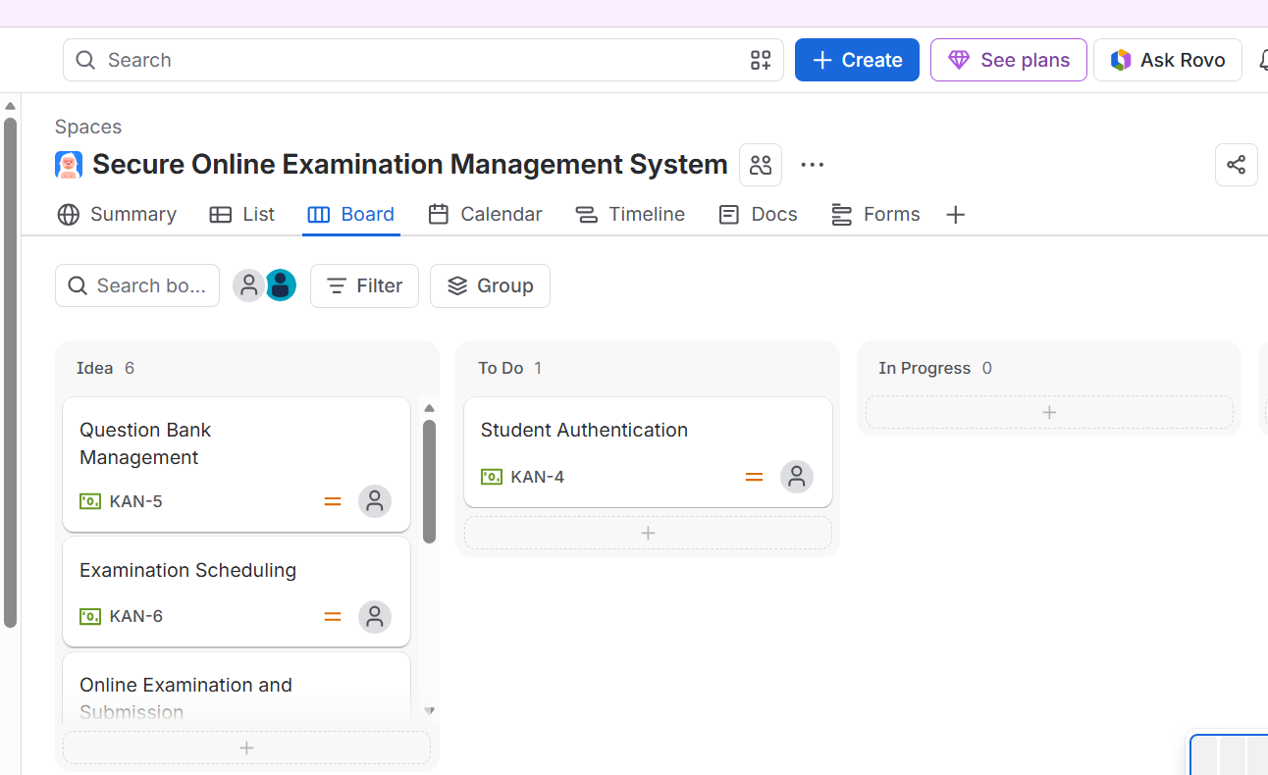

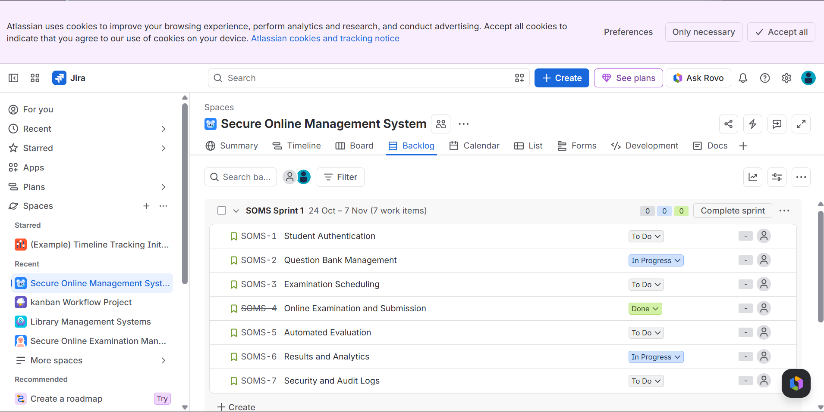

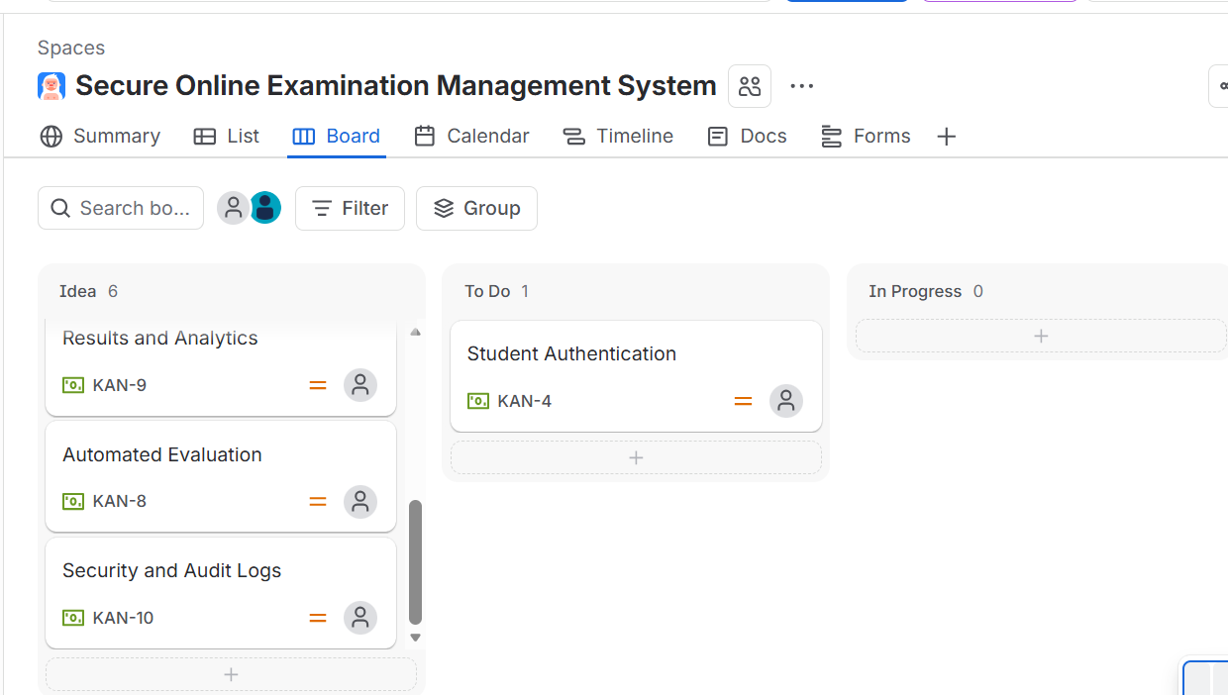

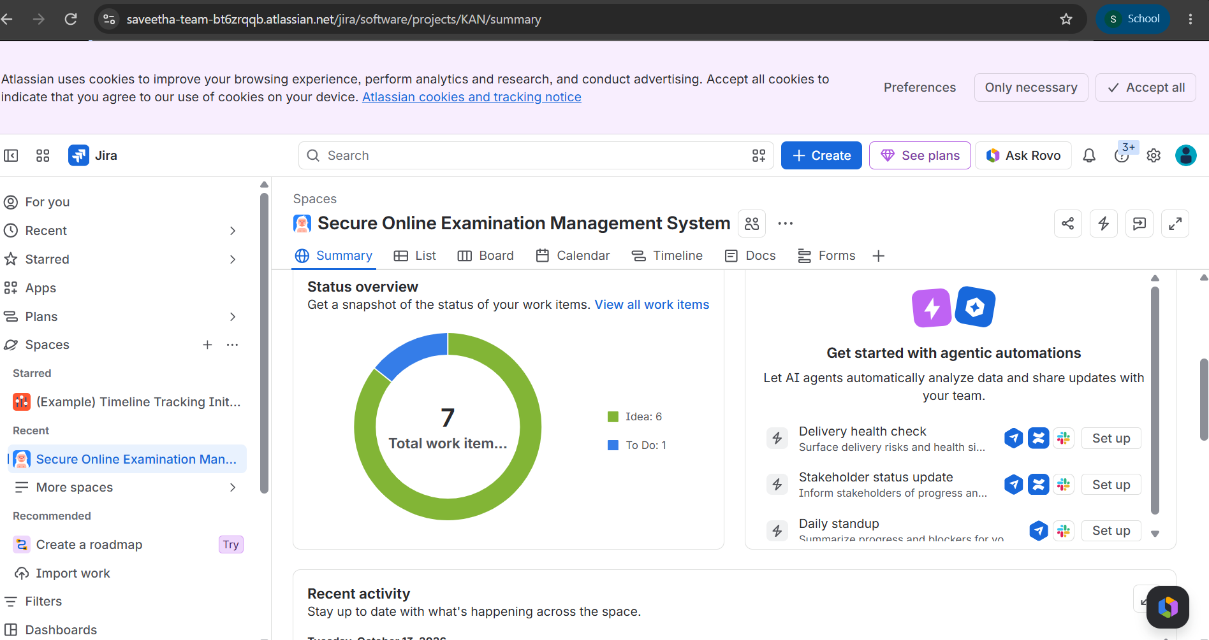

Rubrics for Calculation
Criteria | Excellent (5 Marks) | Good (3 Marks) | Satisfactory (2 Marks) | Needs Improvement (1 Mark)
Problem Understanding (30%) | Clearly explains the problem, objectives, and scope with complete understanding. | Explains the problem with minor omissions. | Basic understanding with limited explanation. | Poor understanding; objectives and scope are unclear or missing.
Stakeholder & Challenge Analysis (25%) | Identifies all stakeholders, their roles, and challenges with clear analysis. | Identifies most stakeholders and challenges with adequate analysis. | Identifies only a few stakeholders or challenges. | Stakeholders and system analysis are incomplete or inaccurate.
Current System Analysis (20%) | Thoroughly analyzes the existing system, strengths, weaknesses, and identifies all gaps. | Good analysis with most strengths and weaknesses identified. | Limited analysis with partial identification of issues. | Proposed solution is unclear or inappropriate; requirements are largely missing.
Proposed Software Solution & Software Engineering Principles (15%) | Proposes an innovative, feasible solution applying appropriate software engineering principles (modularity, scalability, maintainability, security, etc.). | Suitable solution with good application of software engineering principles. | Basic solution with limited application of software engineering principles. | Methodology is inappropriate, poorly justified, or not discussed.
Methodology/ Framework Justification (10%) | Selects the most suitable SDLC/model/framework and provides strong technical justification. | Suitable methodology selected with adequate justification. | Methodology selected but justification is weak. | Outcomes, limitations, or future enhancements are missing; report lacks organization and clarity.

Criteria | Mark
Problem Understanding (30%) | /5
Stakeholder & Challenge Analysis (25%) | /5
Current System Analysis (20%) | /5
Proposed Software Solution & Software Engineering Principles (15%) | /5
Methodology/ Framework Justification (10%) | /5
TOTAL | /25

